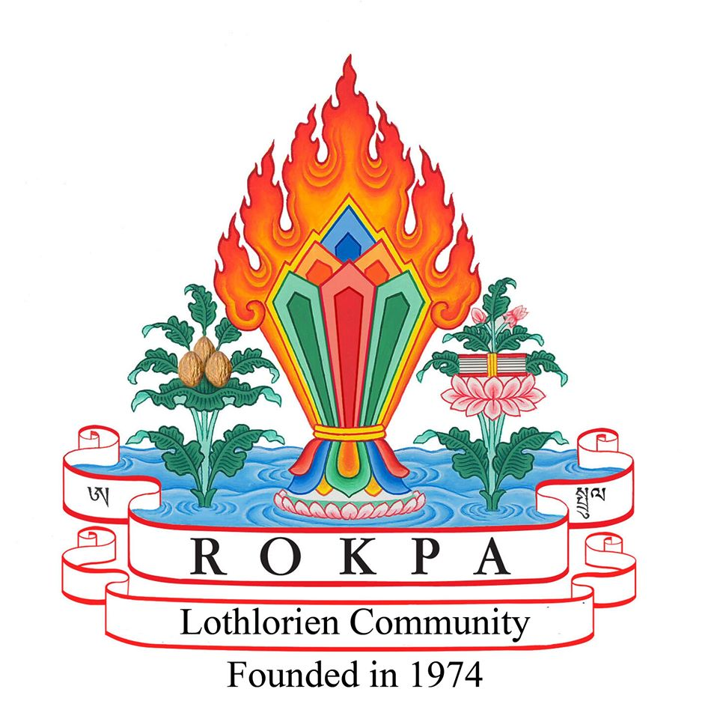

Lothlorien Community (Rokpa Trust)

Resident Application Form
Welcome
Thank you for your interest in Lothlorien.
This application helps us understand your circumstances and whether our therapeutic community is likely to be the right place for you. Once we receive your completed application we will contact your healthcare referees and may request further information where appropriate. All applications are considered individually and submitting an application does not guarantee a placement.
Please answer every question. If a question does not apply, write 'N/A'. All information is treated confidentially.

What happens next?
- 1. Return your completed application form to lucy@lothlorien.tc
- 2. We contact your two healthcare referees.
- 3. We may ask for additional information if required.
- 4. We consider whether Lothlorien is likely to meet your needs.
- 5. We discuss funding options and, if appropriate, offer an initial assessment.

1. About You
Full name
Pronouns
Date of birth
Address
Email
Telephone
Preferred dates of stay
Length of stay requested
Current living situation
Emergency contact (name, relationship, telephone, email)

2. Your Healthcare Team
Referrer (self-referrals welcome)
GP
Current psychiatrist (if applicable)
Diagnosing psychiatrist (if different)
Other professionals involved in your care

3. Your Health and Wellbeing
Please describe your current mental health and any diagnoses you have received.

Please list your current medication (including dosage if known).

What therapies or treatments are you currently receiving?

What support do you currently receive from family, friends or services?

Please tell us about any Mental Health Act detentions, voluntary hospital admissions or Compulsory Treatment Orders.

To help us understand whether we can safely support you, please tell us about any current or previous difficulties with drugs, alcohol, self-harm or suicidal thoughts or behaviours.

Please tell us about any significant physical health conditions or disabilities.

4. Life at Lothlorien
Life at Lothlorien includes around three hours of gardening and outdoor activity on most weekdays. How do you feel about taking part? Please include any physical limitations.

Previous employment, education, training or volunteering.

Hobbies, interests and strengths.

Why would you like to come to Lothlorien? What do you hope to gain, and what do you hope to contribute to the community?

Have you ever been convicted of a criminal offence? If yes, please provide details.

5. Healthcare References
Please provide details of two healthcare professionals who have supported your mental health within the last three months.

Reference 1
Name
Role
Organisation
Telephone
Email
Address

Reference 2
Name
Role
Organisation
Telephone
Email
Address

6. Funding and Financial Circumstances
Please complete this section to the best of your ability. This information helps us understand your financial circumstances and consider the funding options that may be available. If you are unsure of any amounts, please provide your best estimate.
Benefit or Income | Do you receive this? | Amount (per week or month)
Employment and Support Allowance (ESA) | ☐ Yes ☐ No | £ __________
Universal Credit | ☐ Yes ☐ No | £ __________
Housing Benefit | ☐ Yes ☐ No | £ __________
Personal Independence Payment (PIP) / Adult Disability Payment (ADP) | ☐ Yes ☐ No | £ __________
State or Occupational Pension | ☐ Yes ☐ No | £ __________
Employment or Self-employment Income | ☐ Yes ☐ No | £ __________
Other income (please specify) | ☐ Yes ☐ No | £ __________
Approximate total income: £ __________________
Savings
Do you have savings of more than £6,000?
☐ Yes ☐ No
If yes, approximately how much? £ __________________
Property
Do you own your own home?
☐ Yes ☐ No
Funding
How do you expect your placement to be funded?
☐ Local Authority / Social Work
☐ NHS
☐ Self-funding
☐ Benefits or personal income
☐ I am unsure and would like to discuss this
☐ Other (please specify): ______________________________________
Additional Information
Is there anything else you would like us to know about your financial circumstances or any funding applications that are already in progress?

7. Privacy Notice
Lothlorien is operated by the Rokpa Trust. We are committed to protecting your personal information and handling it responsibly.
Why we collect your information
We ask for personal and health information so that we can:
- assess whether Lothlorien is the right service for you;
- contact you about your application;
- obtain references from the healthcare professionals you nominate;
- arrange visits and, where appropriate, an introductory stay;
- meet our legal and regulatory responsibilities.
What information we collect
As part of your application, we may collect information about your:
- contact details;
- health and support needs;
- current care and treatment;
- financial circumstances (where relevant);
- healthcare professionals and references.
Who we share your information with
We will only share your information where necessary, for example with the healthcare professionals you nominate, NHS or Local Authority services involved in your care, or where required by law.
Your rights
Under UK data protection law, you have the right to:
- request access to your personal information;
- ask us to correct inaccurate information;
- request that we restrict or erase information where appropriate;
- make a complaint to the Information Commissioner's Office (ICO).
If you have any questions about how your information is used, please contact Lothlorien.
8. Consent and Declaration
I give permission for Lothlorien to request relevant psychiatric, medical, social work and benefits information in support of this application. I understand that I may withdraw this consent in writing at any time.
Information will be stored securely and handled in accordance with UK data protection legislation.
Applicant signature
Date

