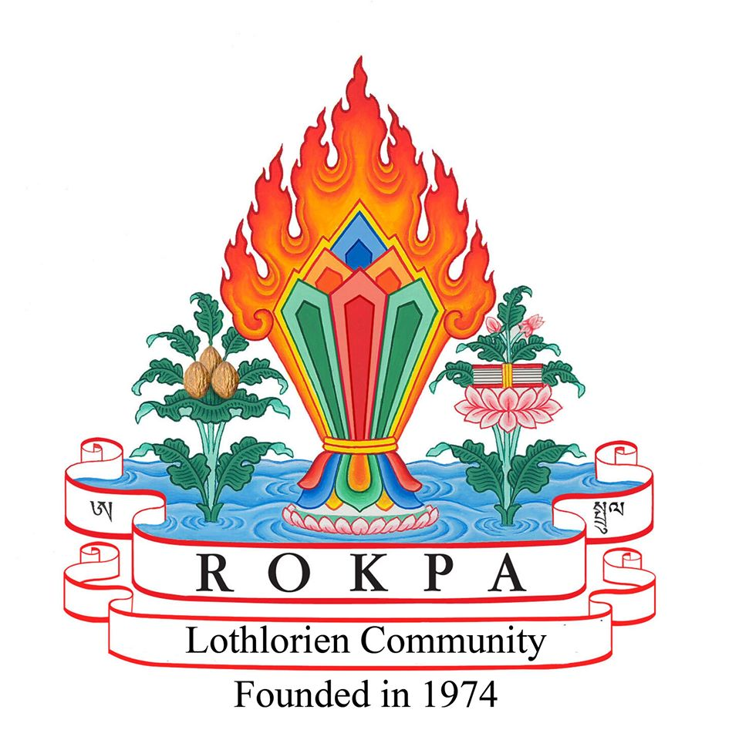

Welcome to Lothlorien
Information for Prospective Residents

Welcome
Thank you for your interest in Lothlorien. Deciding whether to apply to a therapeutic community is an important step, and we hope this information helps you decide whether Lothlorien could be a good fit for you. It explains how we work, what you can expect from us, and what we ask of our residents.

What is Lothlorien?
Lothlorien is a therapeutic community operated by the Rokpa Trust. We provide a supportive residential environment for adults experiencing mental health difficulties who would benefit from living within a structured, caring community.
Everyday life at Lothlorien is part of the therapeutic process. Recovery happens through living, working and learning alongside others. Meaningful activity, shared responsibility and supportive relationships are central to how the community works.

Living at Lothlorien
Residents are expected to take part in community work and contribute to the day-to-day life of the community as much as they are able. We recognise that everyone is at a different stage of their recovery, so each person is supported to participate at their own pace.
Life at Lothlorien includes opportunities to:
- Share meals with others.
- Take part in community meetings.
- Help care for the gardens and grounds.
- Contribute to household tasks and shared spaces.
- Join in creative, practical and therapeutic activities.
- Develop confidence, independence and supportive relationships.

A Typical Day
Life at Lothlorien follows a regular daily rhythm, with the organised programme beginning each weekday at 9.45 am. Days are structured around community meetings, shared meals and meaningful activities, while allowing time for regular breaks and relaxation.
A central part of life at Lothlorien is community work. This includes practical tasks such as gardening, preparing meals, caring for the house and grounds, and other activities that help the community to flourish. Everyone is encouraged to contribute according to their own abilities, and support is always available.
Alongside community work, there are opportunities for creative activities, relaxation sessions, discussion groups and individual appointments as appropriate.
While weekdays follow a structured programme, evenings and weekends provide plenty of time to relax, pursue personal interests and enjoy the local area.

Is Lothlorien Right for Me?
Lothlorien may be suitable if you:
- Are aged 21 or over.
- Are experiencing mental health difficulties.
- Would benefit from living in a therapeutic community.
- Are willing to participate in community life.
- Can live respectfully alongside other residents.
- Wish to work towards your recovery with the support of others.
Every application is considered individually. We recognise that everyone's circumstances are different.

When Lothlorien May Not Be the Right Place
Sometimes another service may be better placed to meet a person's needs. For example, if someone:
- Requires a level of care or support that we are unable to provide.
- Is unable to participate safely in community living.
- Has needs or risks that cannot safely be managed within our therapeutic community.
- Is experiencing active drug or alcohol dependence, as this can make it difficult to engage fully with community life and the therapeutic programme.
In general, applicants should have established a period of stability and abstinence before applying, so that they are able to benefit from the therapeutic community environment.
If we think another service would better meet your needs, we will explain why.

Visit Before You Decide
If following our assessment process, we believe that Lothlorien may be a suitable place for you, we will usually invite you to visit for a day. This gives you the opportunity to meet residents and staff, look around the community and ask any questions you may have.
If the day visit is positive for everyone involved, we will normally invite you to spend up to two weeks living at Lothlorien. During this introductory stay, you can experience everyday community life, take part in activities and decide whether Lothlorien feels like the right place for you. It also allows us to get to know you better and confirm that we are able to meet your needs before any longer-term placement is offered.

Applying for a Place
The admissions process usually involves:
- Completing the Resident Application Form.
- Providing details of two healthcare professionals who know you well.
- We review your application and obtain references.
- If appropriate, we invite you for a day visit.
- If the visit goes well, we may invite you to stay for up to two weeks.
- Together, we decide whether Lothlorien is the right place for a longer-term placement.

Fees and Funding
The current residential fee is £982 per week.
Placements may be funded through statutory services, by the individual or through other arrangements. The application form asks for information about your financial circumstances so we can understand your situation and discuss possible funding options during the admissions process.
If you are unsure how a placement could be funded, please contact us before applying. We will be happy to discuss the funding options that may be available and whether there is a realistic route to a placement.

What We Ask of Our Residents
Living in a therapeutic community means being willing to take an active part in community life. Residents are expected to:
- Treat other residents, volunteers and staff with respect.
- Attend community meetings, community work and other agreed therapeutic activities, participating to the best of their ability.
- Take shared responsibility for the everyday life of the community by contributing positively to the home and its environment.
- Respect the house, gardens and shared spaces.
- Let staff know if they are struggling or are unable to take part, so that appropriate support can be provided.
- Respect the privacy, dignity and wellbeing of other residents.
Participation in community life is an important part of the therapeutic programme. We understand that everyone has difficult days and people are encouraged to ask for support when they need it. However, a willingness to engage with the programme and work alongside others is an important part of living at Lothlorien.

Contact Us
If you have any questions about Lothlorien or the application process, please contact us. We will be happy to discuss whether Lothlorien may be the right place for you.

